
Housing Price Prediction Project

Submitted by:
Gondesi Siva Ram Santosh Reddy

ACKNOWLEDGMENT

I wold like to add some refresences which helped me to solve this project

For data analysis part i have used pandas, you can find the link below

https://pandas.pydata.org/

And for visualization i used matplotlib, seaborn,sweetviz for generating report and yellowbrick for vistualizing the metrics of the data

https://matplotlib.org/

https://seaborn.pydata.org

For visualizing the residual plots and other error plots i used yellobrick
https://www.yellowbrick.co

for some statistical analysisi i have used scipy
https://www.scipy.org

And at last for numerical calculation i used Numpy and Scipy
https://numpy.org

INTRODUCTION

- Business Problem Framing

Houses are one of the necessary need of each and every person around the globe and therefore housing and real estate
market is one of the markets which is one of the major contributors in the world’s economy
A US-based housing company named Surprise Housing has decided to enter the Australian market.
The company is looking at prospective properties to buy houses to enter the market. You are required to build a model
using Machine Learning in order to predict the actual value of the prospective properties and decide whether to invest
in them or not. For this company wants to know:
- Which variables are important to predict the price of variable?
- How do these variables describe the price of the house?

- Conceptual Background of the Domain Problem
A US-based housing company named Surprise Housing has decided to enter the Australian market. The company usesdata analytics to purchase houses at a price below their actual values and flip them at a higher price. For the same
purpose, the company has collected a data set from the sale of houses in Australia. The data is provided in the CSV filebelow.The company is looking at prospective properties to buy houses to enter the market. You are required to build a model,using Machine Learning in order to predict the actual value of the prospective properties and decide whether to invest in them or not. For this company wants to know:
- Which variables are important to predict the price of variable?
- How do these variables describe the price of the house?

- Review of Literature
By the problem statement we can say that sunrise homes are starting a venture and want to enter into australina market, so they gives us some data through which we have to find which variable is important and which variables describe the data , and to solve this we should have both domain knowledge and also some skills of data scientist to make a good model

- Motivation for the Problem Undertaken
As a datascient we have tools and kowledge to handle the such data and draw insights from the data to easily visualize and represent the the way we can both visually and statistically so we have to use that data to develop a model so that it will predict the prices and also shows which features are important

Analytical Problem Framing

- Mathematical/ Analytical Modeling of the Problem
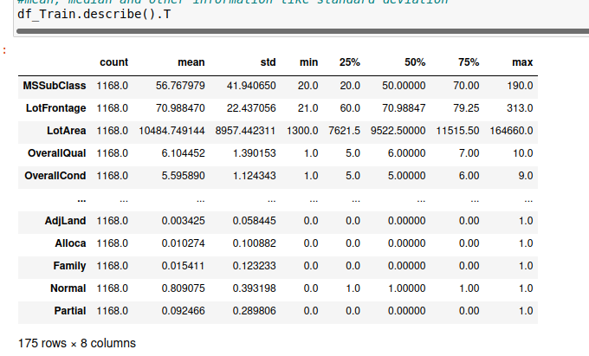

We used many statistical and mathematical function used in the project in python we have a library called pandas where we have some statistical functions like .describe() where we are checking some statistical informations like mean, median, standard deviation and percentils
And there are so many other functions like z scores and IQR which are used in outliers detection and treatment and cheking the correlation and covarience of the data, by the analysis of the data set we found that there are many outliers in the data only some of them are handled and also data is skewed which are handled using power-transform method

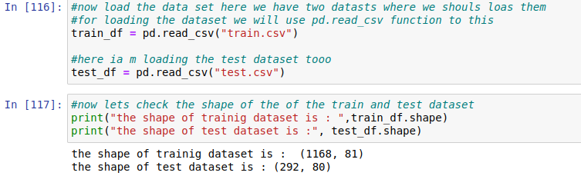
- Data Sources and their formats

Data is provided by our client in the format of .CSV format we have to analyze the data using pandas library used in python
we can see by the above screenshot and we have total 80 rows and 1168 observations in the data that is provided and it is a big dataset, there are no null values in the dataset, and also we have test dataset which has 80 dimensions and 292 records

- Data Preprocessing Done
There is much dataprocessing should have been done in this dataset, we have combination of both numerical data and also categorical data, so we have to first to find the null values in the data and next we have to endode the categorical columns so that we can have good amount of cleaned data,and later we have to check the for outliers and skewness measurement
And we have dropped some columns as they ar no use, and if we carefully observe the data sets test data differs a little than the training so i have merged the both datasets and then apply changes and then divided into test and train datset

- Data Inputs- Logic- Output Relationships
if we observe the datsets carefully we have 81
dimensions and we have to to reduce them cuz if the
if the dimensions increased inthe dataset the accuracy
of the model suffers all the features will not have good
relation with the target data but model only
priorotizes some of thefeatures and remaining are
given least importance, and then we eill encode the
variables and and then we will create the model

- State the set of assumptions (if any) related to the problem under consideration
We have to biuld a machine learning model based on the the input data given to us and we have to predict the prices of the house and also the important features that are useful to predict the prices

- Hardware and Software Requirements and Tools Used
There is no specific details about hardware specifications, but when we come to sofware specifications we should have python installed along with anaconda navigator where we have to install jupyter notebook with all libraries like Numpy, scipy and matplotlib and other some libraries to be installed, and for moddel creation we have to install scikit learn, if you have a plaptop of low configuration then we have Google colab which is a great alternative choice, but wuth a great connetivity.

Model/s Development and Evaluation
In model building and evaluation we have to first install
scikit-learn library aong with the python

- Identification of possible problem-solving approaches (methods)
Regarding this project we have used many methods for both statisticaly nad mathematiclly and for analysis we have used many mehods like
.head() for displaying the first 5 columns of the dataset
.describe() displays statistical details of the dataset
.isnull() displays the nullvalues in the dataset
.nunique() to display unique data of all columns
.corr() for checking the correlation between variables
.cov() for creating covarience matrix for PCA method
.drop() to drop unnecessay columns in the dataset
.skew() to check the skewness of data
And we have used many methods from scikit learn like
We are using many scaling methods like Standardscalar() to standardize the data, Robustscalar to adjust the outliers and the power_transform for adjusting the skewness and to scale the data that is used in model building, as all the machine learning models only require normalized data to create models
There problem with the dataset is it is a big dataset tht has 81 dimensions, as the dimensions increases the the models learning efficiency decreases eading overfitting of the model this is due to concept called”The curse od dimensionality” where the dimensions of the data increases the model accuracy suffers
We have to reduce the dimensions or create a model and get the important features by that model and so that wecan reduce the mi cantuse another dimensionality reduction techniques as it like PCA but we need to show the importance of the features so lets go ahead and apply regularization as it gives appropriate results

- Testing of Identified Approaches (Algorithms)
Now we are ready with the dataset we will nows tart building the model i am going to use some of the regression models like linear regression and some regularizations like Lasso and Ridge, along with ensemble techniques like randomforest regressor and Ada boost regressor
By the cross validation we can see the models score
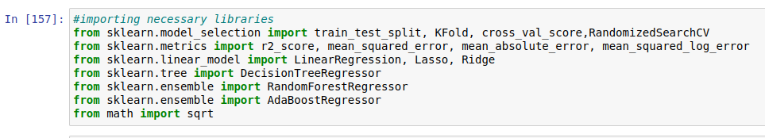
i am going to predict using normal model prediction
and find the score difference we get the best model with
low difference

- Run and Evaluate selected models
we are going to predict using normal algorithms and we will see hows it going to work and whats the accuracy be
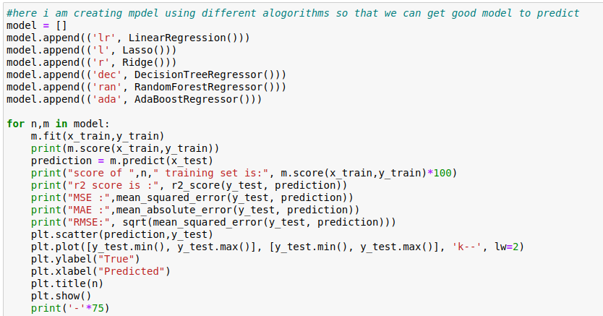
Now tlets check the metrics of the model in refression we will use r2score, Mean squared error, Mean absolute error and Root mean squared error, the main metric function we have to observe is RMSE where we shouuld have low

In this we can see we have accuracy score an other metrics of Linear regression, lasso and ridge
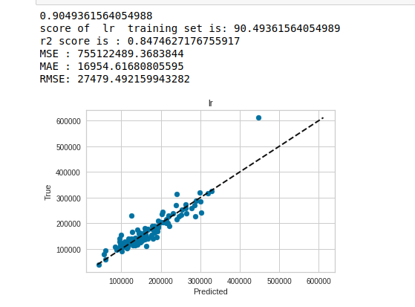
we have all scores and metrics of the models and when
compared with the cross-val-scores we got random forest
as the best model , so i am gona pick random forest and
continue with hyperparameter tuning and savong the
model

- Key Metrics for success in solving
problem under consideration

when we talk about the key metrics we have r2score, mean square error, mean absolute error and root mean square error and at first we will check cross validations score of the model that we will use in the model

- Visualizations

visualizing is the most importinant thing in the daascience where we wanto torespresent the data into visual form so that clients can understand that easily and and also we can show the relation of each variable and aslo mainly with the target variable, in this project i have used many visualization where iused to represent hte data and also the relation with the target variable
we can used different types of visualization for different situations
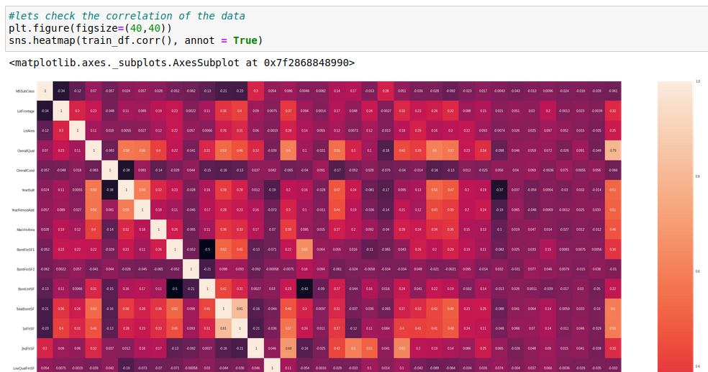
here come the heatmap we will use it for the correlation which shows the correlation betwee the variables
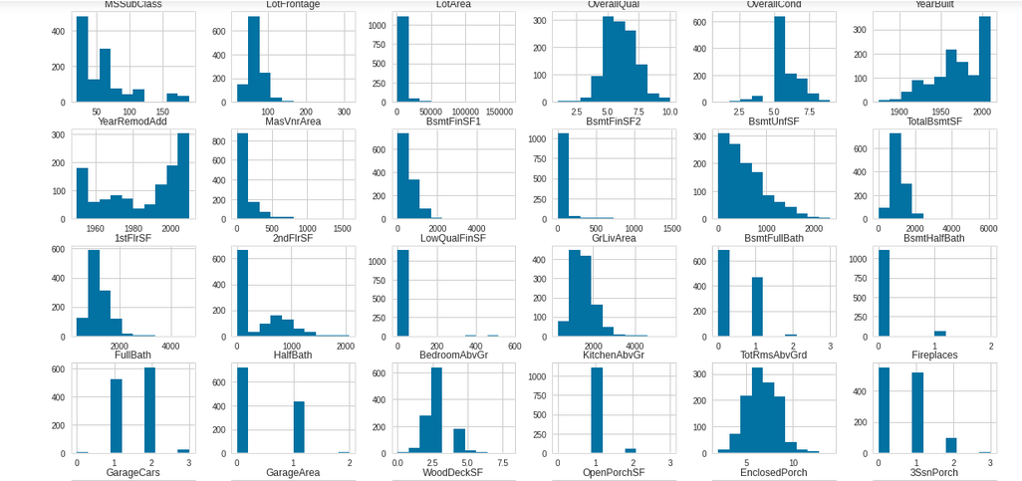
these are histograms which shows the data datstribution of the data along with the ranges in the data, actually numrical variables and catrgoriacal variables contains different plots which shoud be understood and to be used
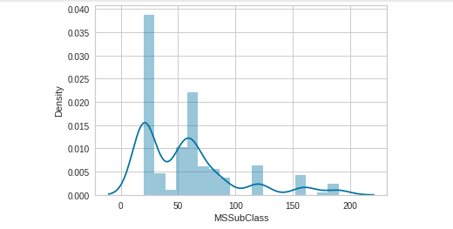
these plots are called distplots which shows us about the distribution is noramlized or not because most of the machine learning models deals with the nrmalized data with the help of these plots we can apply which plot should ue at what time

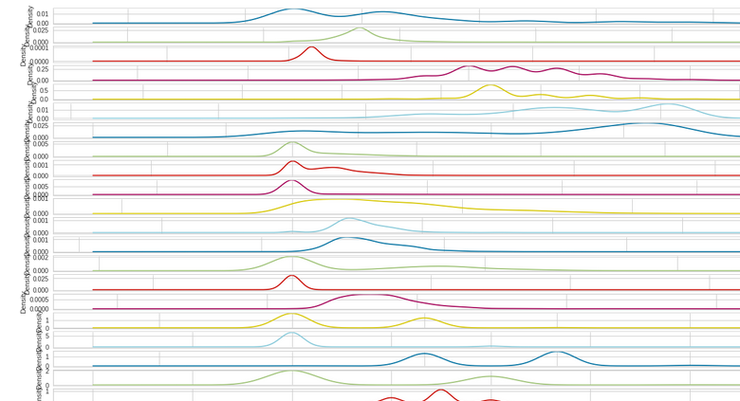
Density plots deals with the densities of the data and with these plots we can tell the data
varience

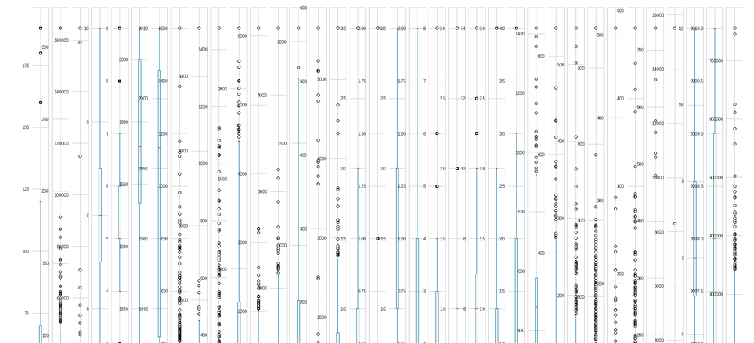
Outliers detection and removal one of the most important proces of the machine learning project here we have to find the outliers and we shoutld remove them before proceeding to the project, plots which bassically used forout lier detction are boxplot and scatterplot

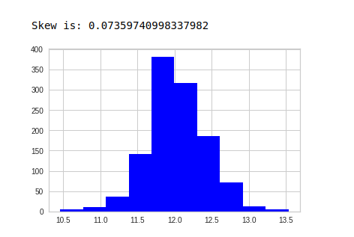

some time histograms are use ful in skewness detection and adjusting
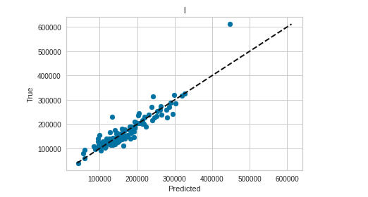
these are scatterplot which is ploted againt the training and testing data which can bes seen in above plot

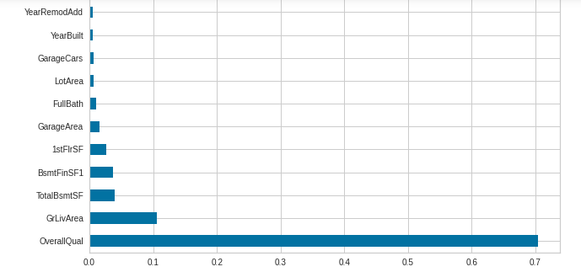

this is a type of histplot where we ploted against moddel impotant features where we can see which feature is important
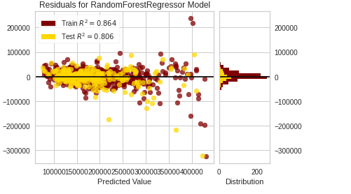

these are called residual plots we will plot the testing set against training set along with the histogram
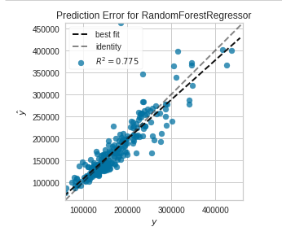

this plot is also a scatterplot where plotting is done with the training and testing set which shows the best fit and identity line

- Interpretation of the Results
Two types of datasets are present with the problem statement one is training data with 81 dimensions nad 1168 records and another test dataset with 80 dimensions and 292 records
By the problem solution we have to create a machine learning model which predicts the prices of te houses based on the data providedand
Then using the model we have to use it to preict the prices using the test dataset when i bserved the test set we dont have one problem with it most of the datasets have multiple categorical data that dont match with the train set so we need to concatinate the both trainig and testing datasets and later we can divide them
we have soma nul values also at first we have to replace the nul values and then we have to encode th categorical columns and then we have to divide the test and training data after that scale the data accordingly, we have to predict the prices here i am using linear regression along with the regularizations Lasso and ridge and i want to include ensemble techniques like random forest regressr and aaboost and then checking the metrics of the regression and
later appying the model on test set to find the predction price values

CONCLUSION
- Key Findings and Conclusions of the Study

Two types of datasets are present with the problem statement one is training data with 81 dimensions nad 1168 records and another test dataset with 80 dimensions and 292 records
By the problem solution we have to create a machine learning model which predicts the prices of te houses based on the data providedand
Then using the model we have to use it to preict the prices using the test dataset when i bserved the test set we dont have one problem with it most of the datasets have multiple categorical data that dont match with the train set so we need to concatinate the both trainig and testing datasets and later we can divide them
we have soma nul values also at first we have to replace the nul values and then we have to encode th categorical columns and then we have to divide the test and training data after that scale the data accordingly, we have to predict the prices here i am using linear regression along with the regularizations Lasso and ridge and i want to include ensemble techniques like random forest regressr and aaboost and then checking the metrics of the regression and
later appying the model on test set to find the predction price values

Later that we need to try hyper paramter tuning for tuning th performance of the model of all the algorithms i have used and getting best parameters for getting good prediction

- Learning Outcomes of the Study in respect of Data Science
From this project we can learn about many things like how to handle bigger data and how to handle the the nullvalues and how to check the sewness and the outliers along with handling them and also dividing the dataset checking the metrics of the dataset and many other thing, the main important thing is that we can learn how to adjuset the metrics of the model

- Limitations of this work and Scope for Future Work
There is only one limitation in the dataset that is the dimensions in the dataset where we have to reduce the dimensions of the data in order to achieve good results, if we reduce the data dimensions in the dataset we may achieve good results

